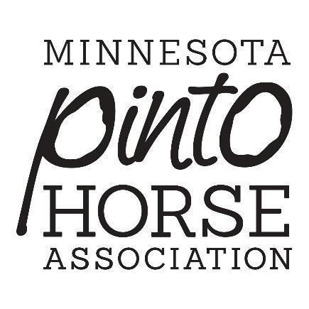
2026 Sponsorship Form

Name:

Business name:

Address:

Email:

Total Sponsorship Amount: $

Preferred use of funds/items:

Email:

Phone:
This completed form and a check made out to MPtHA can be mailed to:
Vonda Morrison
2795 250th St E
Farmington, MN 55024
Or you can email the form and pay via PayPal! mptha66@gmail.com

THIS SECTION WILL BE COMPLETED BY MPtHA

Payment Method: Cash Check PayPal

Payment collected by: ____________________________________________

Date: _____________________

